**NETWORK TRAFFIC MONITORING PROJECTS**

**TOOL:** Better-cap.

**SOFTWARE:** Kali Linux

**DESCRIPTION:**

* Using better-cap is a powerful, flexible and portable tool created to perform various types of man in the middle attacks against a network, manipulate, protocols traffic in real time, sniff for credentials and much more.
* In better-cap can use the command like arp.spoofing to find out network traffic and find out the victims data packets.
* By using the better-cap tool we can intercept and monitor the data packets transferred in the router. Even though we can crack the username and password also by using better-cap.

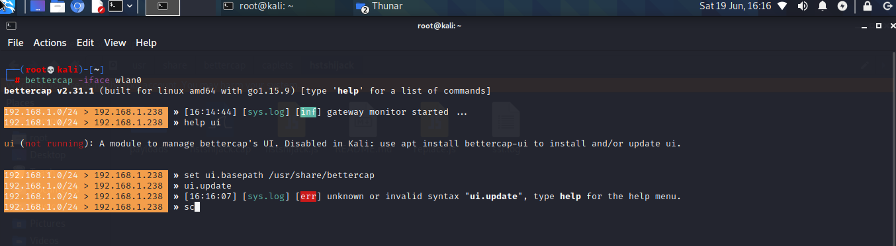

* A very fast port scanner.
* A powerful network sniffer for credentials harvesting which can also be used as a network protocol fuzzer.
* ARP, DNS, NDP and DHCPv6 spoofers for MITM attacks on IPv4 and IPv6 based networks
* bettercap is a powerful, easily extensible and portable framework written in Go which aims to offer to security researchers, red teamers and reverse engineers an easy to use, all-in-one solution with all the features they might possibly need for performing reconnaissance and attacking [WiFi](https://www.bettercap.org/modules/wifi/) networks, [Bluetooth Low Energy](https://www.bettercap.org/modules/ble/) devices, [CAN-bus](https://www.bettercap.org/modules/canbus/), wireless [HID](https://www.bettercap.org/modules/hid/) devices and [Ethernet](https://www.bettercap.org/modules/ethernet) networks.